FuturisticOSM

* Os Mockups Futuristic Never!

Part 1

Windows Never Released

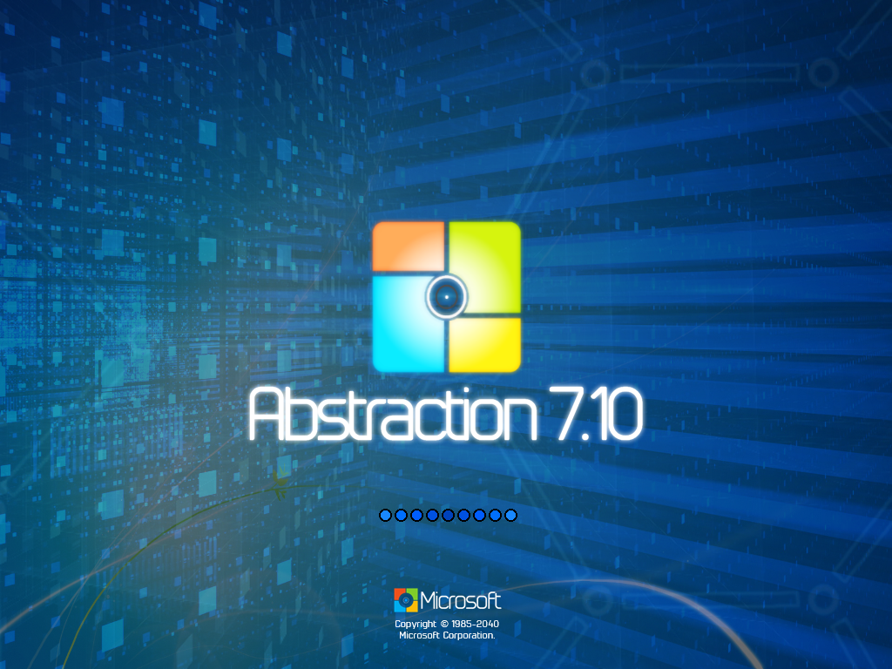 Part 2:

OS Mockups

